**Wir beschreiben Personen**

Name: ____________________________

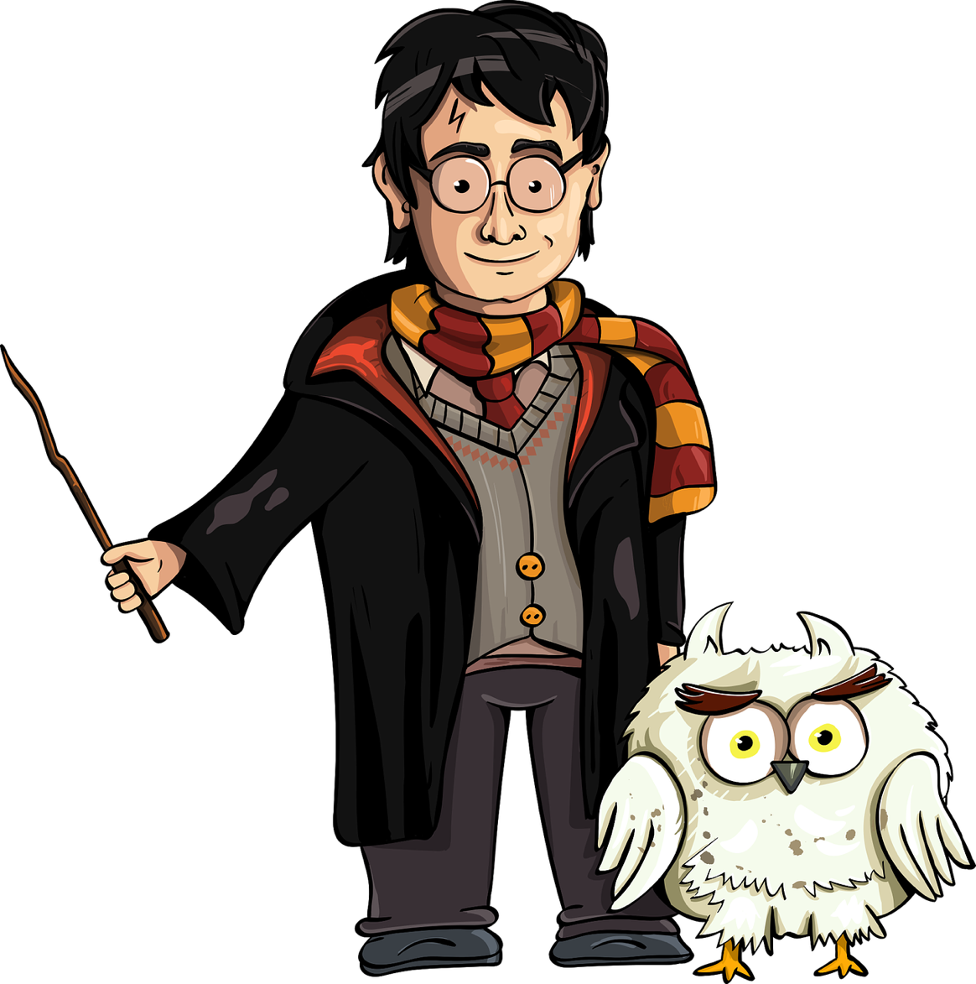

Geschlecht: _______________________

Alter: ____________________________

Größe: ____________________________

Statur: ___________________________

Haare: ______________________________________________________

___________________________________________________________

Gesicht: _____________________________________________________

____________________________________________________________

Kleidung: ____________________________________________________

________________________________________________________________________________________________________________________________________________________________________________________________________________________________________________

Besonderheiten: ______________________________________________  
____________________________________________________________________________________________________________________________________________________________________________________