Finding signs of gender diversity in your city

I looked for signs of gender diversity in Leipzig and here are some of the pictures I took. You can use them in your class or just for inspiration to look for other signs.

This picture shows two portable toilets. They show symbols of people who need to pee. The connection to gender diversity is, that public toilets are often selected into men’s toilet and women’s toilet. To show which bathroom is for which gender, often symbols are used to portray either a man or a woman. The woman is often shown in a dress, the men is not.
You can think about whether those symbols are inclusive or exclusive and why they might be necessary or why not.
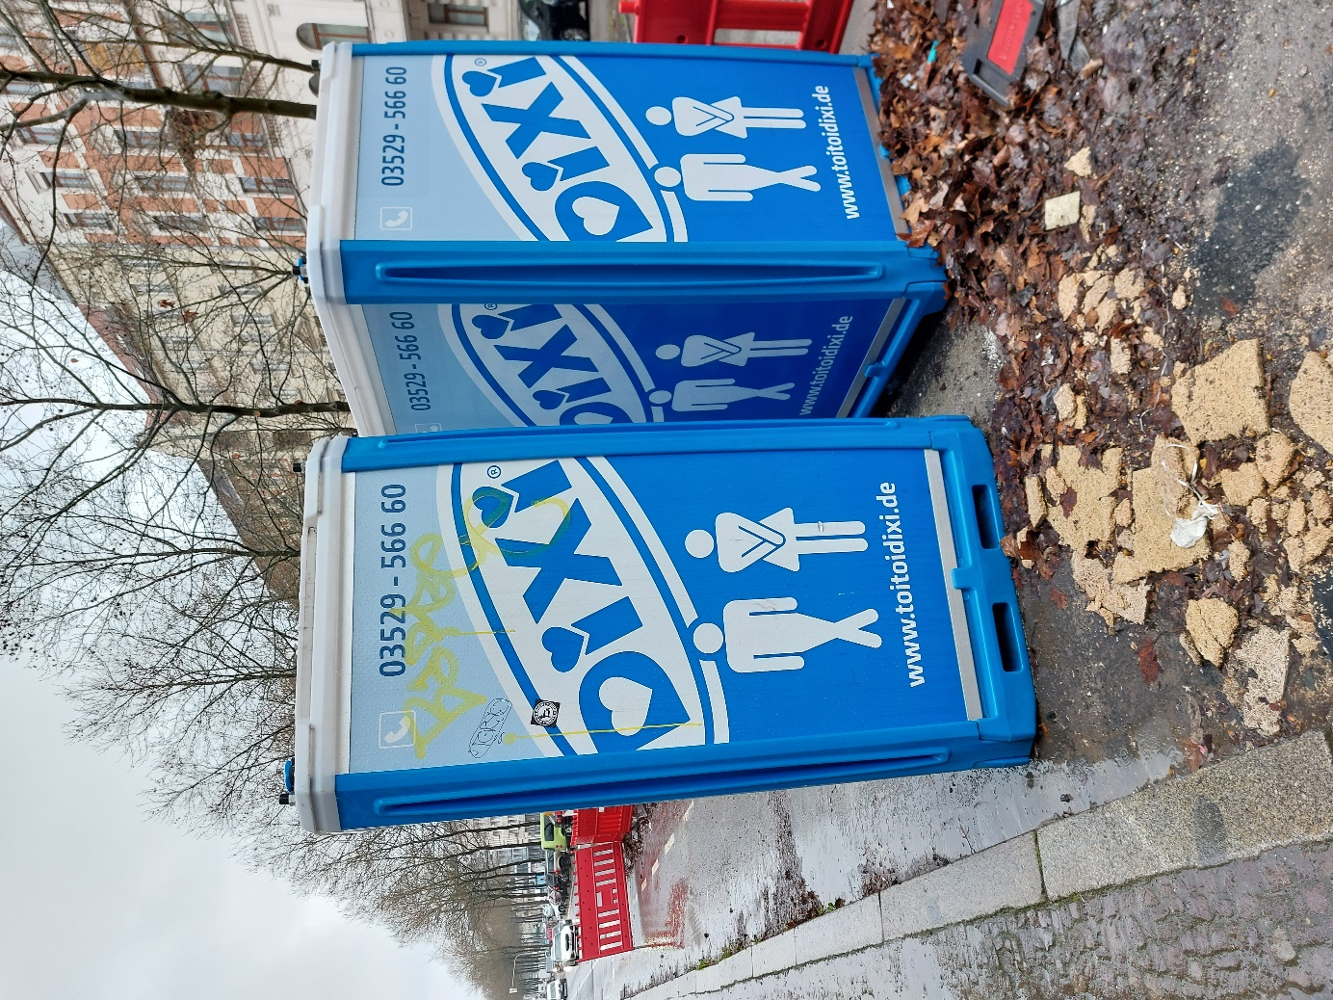

In German, there are different forms of words depending to which gender they refer. By including all genders, this star is used to describe a group of people, so all feel included. Here, it means that this school has a pupils’ council does not only include boys. With the “innen” it is made clear, that also girls can be part of the council and with the star, also other genders can be included.
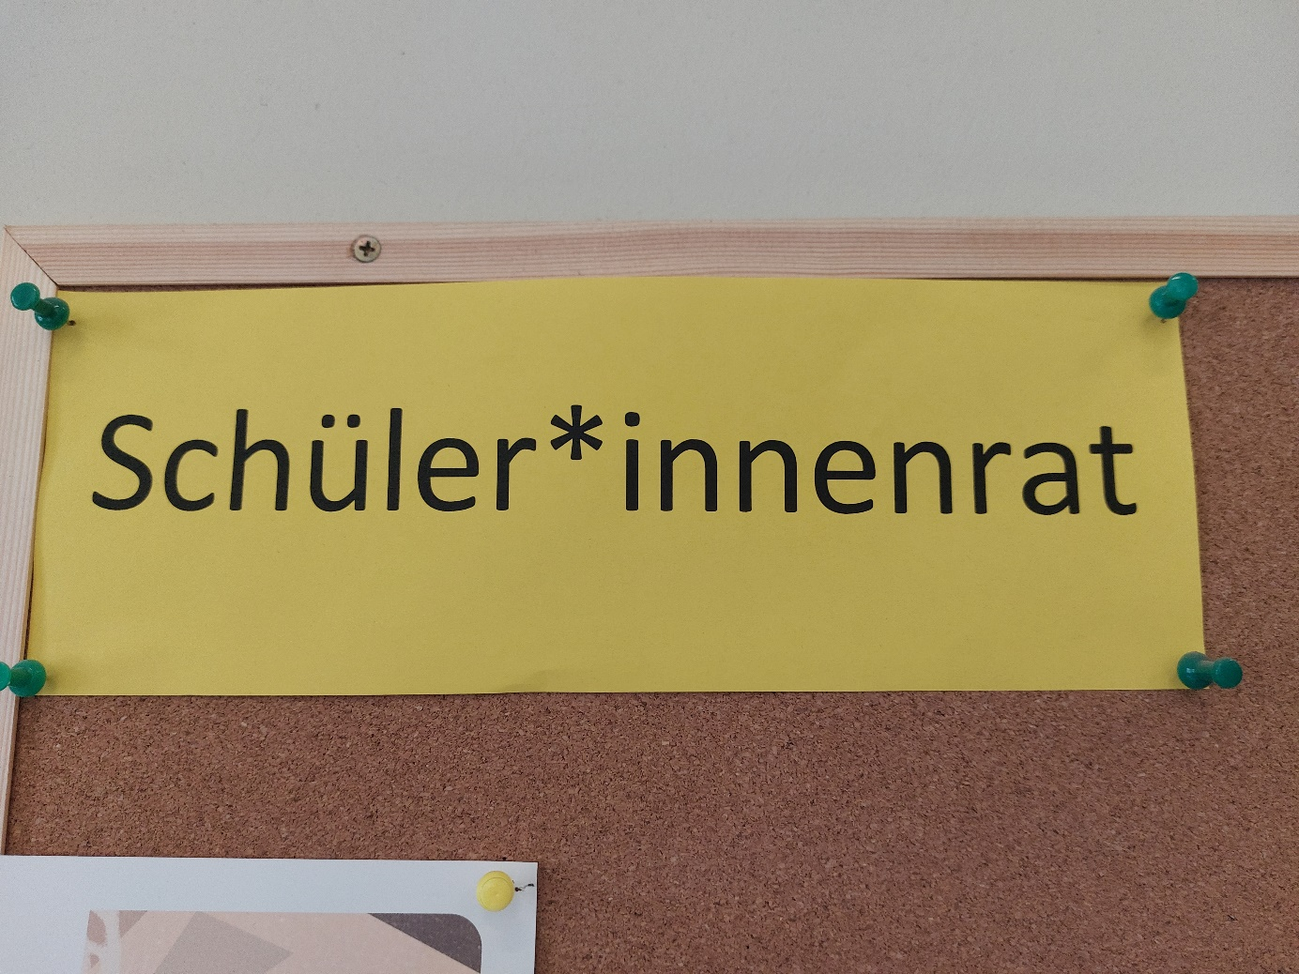

This picture can also be used when talking about sexual diversity, because it says “love for all”. It not only refers to having an open mind about sexuality but also to letting everyone love who ever they want to love. Therefore, it can also be used when talking about gender diversity. No matter what gender you identify with or do not identify with, you should be allowed to love whoever you want.
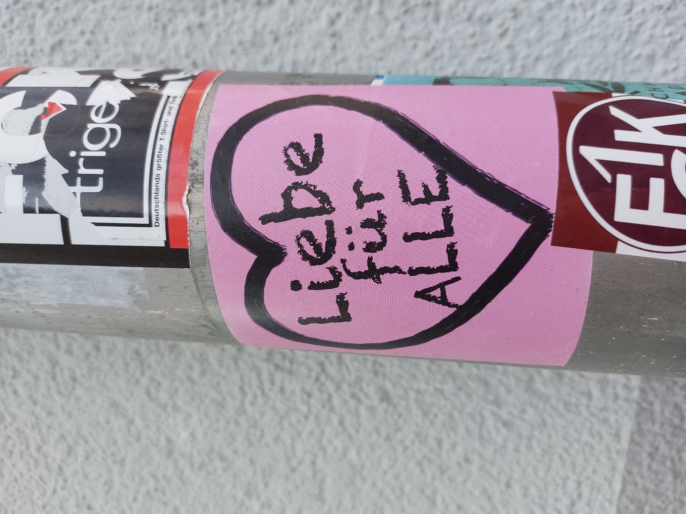

Again, a symbol to represent people. Here, you can talk about gender roles. Why are women often shown in a dress? Would it be so bad to show a man walking around with his child? Why did they choose this symbol?
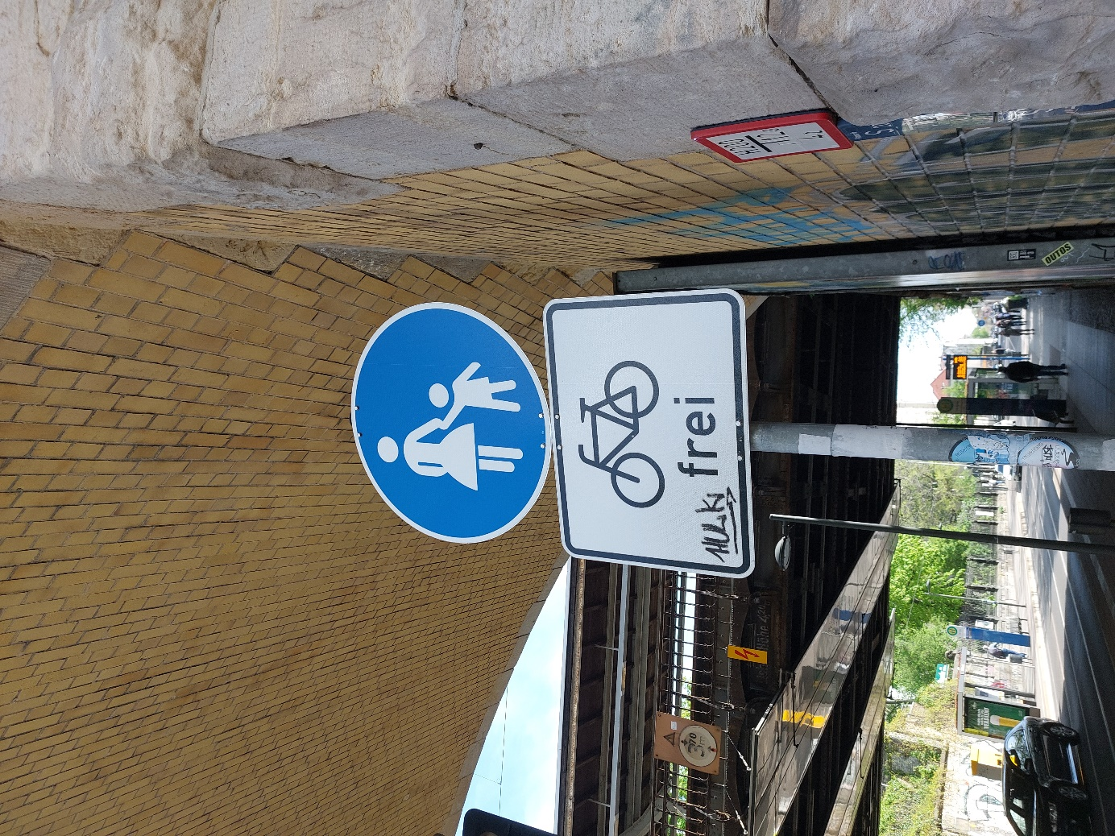

For further inspiration/pictures use the internet or walk around your own city. Good luck & have fun!

