Become part of the



SUSTAINABILITY Movement

**Picture 1**

|  |  |  |  |  |  |
| --- | --- | --- | --- | --- | --- |
| **1.) Do you seperate**  **C:\Users\Thomas\AppData\Local\Microsoft\Windows\INetCache\Content.Word\green-recycling-icon-design-element.jpg your rubbish…**  … at home?  Picture 2  … at school?  … in the city centre?  … at the station? | **no** | **rarely** | **sometimes** | **mostly** | **always** |
|  |  |  |  |  |

1. **Think about the meaning of the slogan!**

Consider its order.

___________________________________________________

___________________________________________________

___________________________________________________

___________________________________________________

___________________________________________________

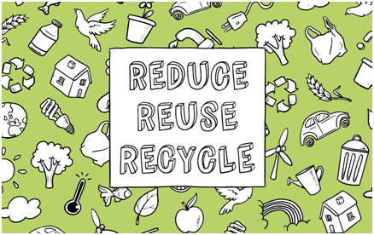

Picture 3

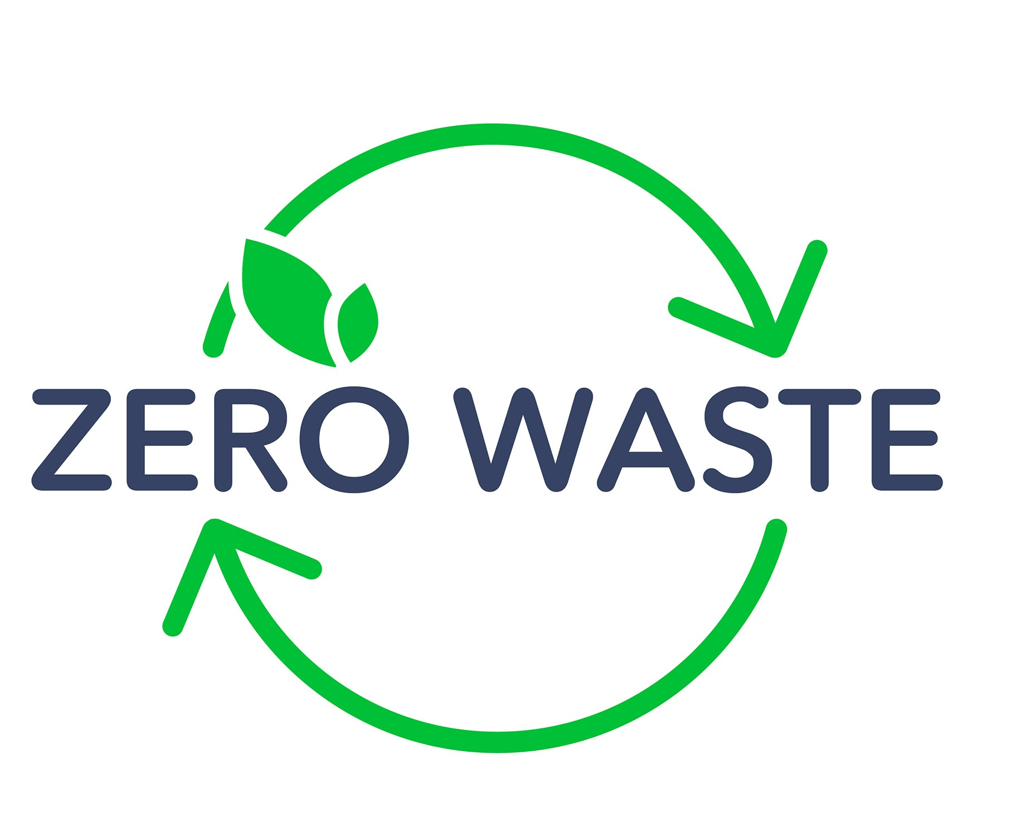

Picture 4

Are you aware of any zero-waste practices?

**_______________________________________________________________________________________________________________________________________________________________________________________________________________________________________________________________________________________________________________________________________________________________________________________________________________________________________________________________________________________________________________________________________________________________________________**

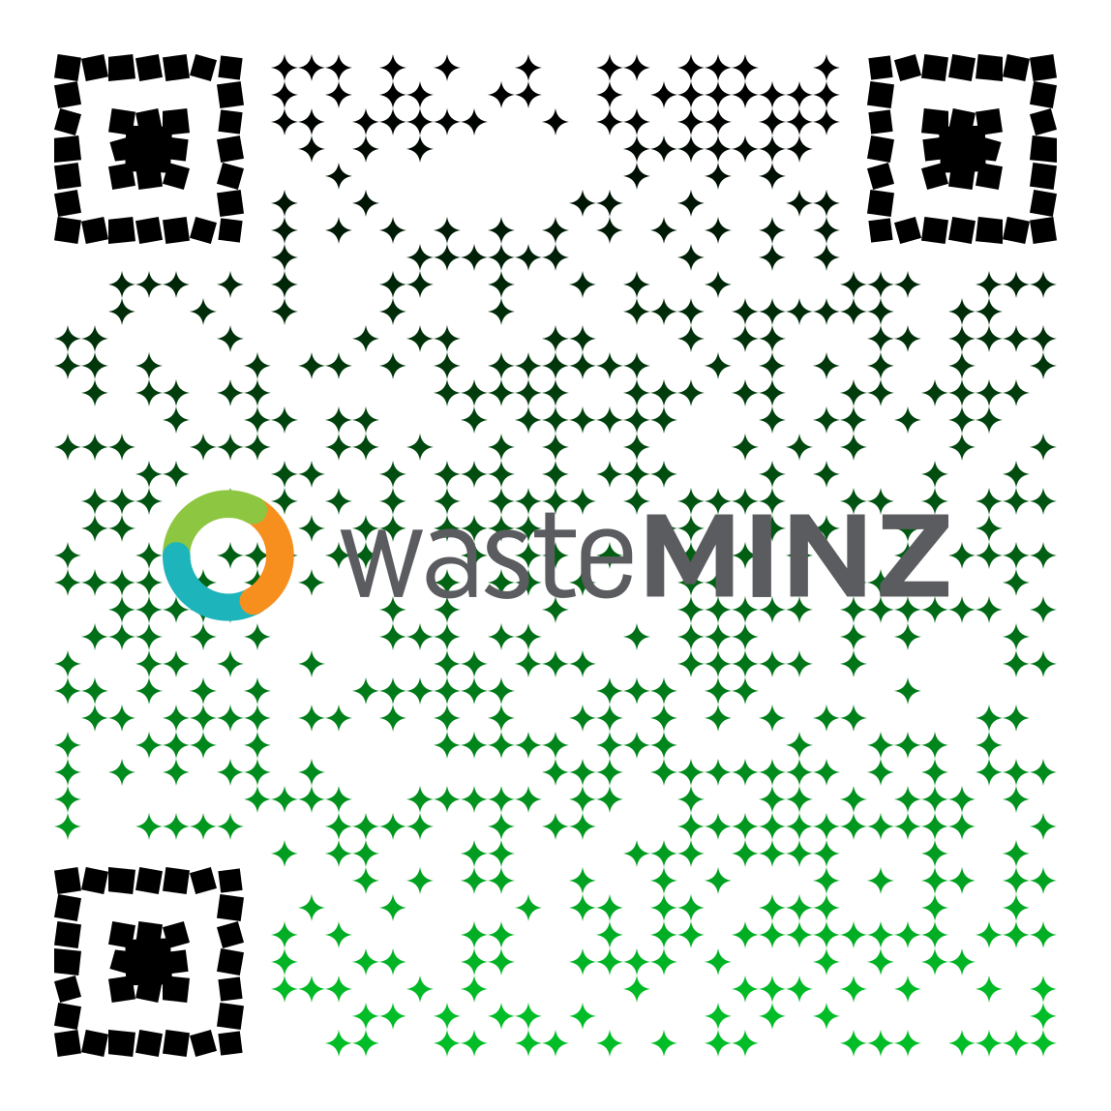 **4.) Quiz it – New Zealand**

**3.) Have you heard of**

**What is it about?**

|  |
| --- |
| Go ahead and **scan the QR code** with your mobile phone.  **Take the quiz!** |

**5.) What goes where?**

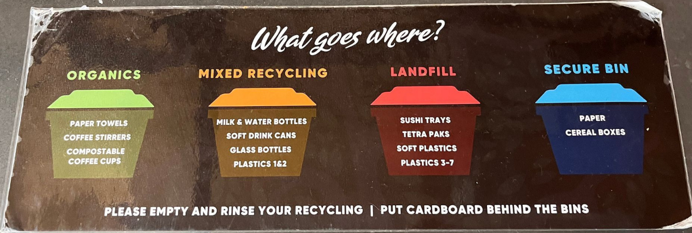This sticker on a public bin shows categories of waste segregation in Auckland, New Zealand.

Picture 5

1. For more information go to recycle.co.nz and find out about the following questions:

* Which categories of sorting do exist?
* What do you notice about the bins?
* What does ‘landfill’ mean?
* What do you find out about the numerical codes on plastics?

1. Compare it to what you know about the German system.

What is similar? What is different? Fill in the table.

|  |  |
| --- | --- |
| **New Zealand** | **Germany** |
| **similarities:** | |
|  | |
| **differences:** | |
|  |  |

1. Which system do you find more convenient and why? Be able to justify your decision.